Item 19

Part A
Identify the major product for the following reaction.
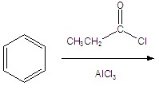
Identify the major product for the following reaction.
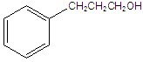
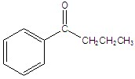
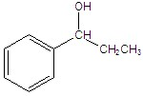
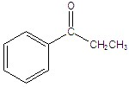
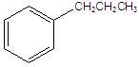

2. Part A
What nucleophile attacks Br2 in the acid-catalyzed α-bromination of a ketone?
What nucleophile attacks in the acid-catalyzed α-bromination of a ketone?
an acetylide
a Grignard reagent
an enolate ion
an enol
a carbocation

